AMF CONTROLLER MANUAL

The information in this document may be subject to change without notice.
No part of this document may be copied or reproduced in any form or any means without the prior written consent of Bernini Design Company. Bernini Design assumes no responsibility for any errors which may appear in this instruction manual or in the wiring diagrams. Although Bernini Design has taken all possible steps to ensure that the User Manual is complete, bug free and up-to-date, we accept that errors may occur.7

Customer Support BERNINI DESIGN SRL ITALY

e-mail: bernini@bernini-design.com mobile: ++40 721 241 361. Tel:++39 335 7077148.

Warranty

Bernini Design SRL (hereinafter BD) warrants that Be-K3 shall be free from defect in material or workmanship for a period of 3 years from the BD delivery date. BD shall, at its discretion, repair or replace the product without charge. BD shall return the Be-K3 to the buyer with the Default parameters at no extra charge. The buyer shall furnish sufficient information on any alleged defects in the product, so as to enable BD to determine their cause and existence. If the Be-K3 is not defective, or the product is defective for reason other than covered by this warranty, the buyer will be charged accordingly. This warranty shall not apply if the Be-K3 has not been used in accordance with the User Manual and other operating instruction, particularly if any defects are caused by misuse, improper repair attempts, negligence in use or handling. This purchase is non-refundable.

This equipment complies with the EMC protection requirements



!! WARNING !!

High voltage is present inside the Be-K3. To avoid electric-shock hazard, operating personnel must not remove the protective cover. Do not disconnect the grounding connection. The Be-K3 can start the engine at anytime. Do not work on equipment, which is controlled by the Be-K3. When servicing the engine, disconnect the battery and battery charger. We recommend that warning signs be placed on equipment indicating the above

!! WARNING !!

The Be-K3 can start the engine at anytime. Do not work on equipment, which is controlled by the Be-K3. When servicing the engine, disconnect the battery and battery charger. We recommend that warning signs be placed on equipment indicating the above.

Alphabetic index

Alternator Failure 9.02A,13.04  Alarms 13.0, 5.05  ALARM 1-2-3 13.2B  Alarm (Horn) TIME-OUT 9.06  Alarm bypass (BYPASS TIMER) 9.03A  Auto mode of operation 2.30  AUTO TEST FAILED 13.01  Automatic Periodic Test 8.00, 8.02  Auxiliary Temperature 9.03E,13.05  Battery (engine) Alarms 13.03  Belt break 13.03  Choke, control(mode 4) 9.03A  CANBUS (+ERROR) 9.11, 13.01  Characteristics 16.0  Charger Alternator/Failure 14.0/9.03  Clock setting, error 6.00 13.01  Clear the memory 10.00  Contactors (use) 2.21  Connectors, Plugs 22.0  Connections list 22.0  Configurable inputs 9.07  Configurable outputs 9.08  COOLANT ALARMS 13.05  Cooling down time 9.03A  Current (over) alarms......... 9.02A,13.04  Current measurements......... 5.01  Crank timing 9.03A  Current Transformer Size 9.02B  Defaults 9.10  Dimensions 21.0  Display & Messages 4.0  Droop settings 9.04  Earth Failure 9.02B, 13.04  ECU SPEED ERROR 13.03  Engine Running 14.0  Engine Alarms Bypass 9.03A  Engine Model 9.11  Engine TYPE 9.11  Engine Parameters 9.03A-B-C-D  Energy counter (clear) 10.00  Emergency (panel) 13.0A  Event history 5.06  Events (clear) 10.00  Fail to Start /Stop 13.03  Front Panel 1.0 Figure 1  Front Panel Emergency 13.02A  Frequency (Mains/Gen) 9.01, 9.02  Fuel Level & Alarms 9.05, 13.06 | Generator control 9.02 A-B  Generator Voltage/Hz 9.02A  Generator Failure 9.02B,13.04  Glow Plugs 9.03A  Hour Counter 9.06  Horn timer Programming 9.06  HIGH BATTERY 13.03  Idle time 9.04  Idle speed 9.04  Inputs (Programmable) 9.07  kW,kVA (Max,Min limits) 9.02B,13.04  KM-KG Failure 13.04  Language selection 7.0  Lamp Test, LEDs 3.0  Low Battery voltage 13.03  Locked by remote control 13.02B  Mains Failure/Restore 9.01  Maximum run time out 8.03  Mains Simulated (option [12]) 9.07  Measurements 5.0  Menu (OEM parameter) 9.00  Maintenance Timers 8.01, 13.08  Memory and Memory Error 18.30, 13,01  Memory (clear) 10.00  MAN (manual mode of operation) 2.20  NFPA-110 9.06, 18.20

OEM Password 11.00  Oil pressure 9.03C,13.07  OIL ALARMS 13.05  Oil temperature page 9.03D  Outputs (programmable) 9.08  Over Current 9.02A  Over Speed 9.04,13.03  Overload input (option [29]) 9.08A,13.04  Over / Under Frequency 9.02A,13.04  Over / Under Voltage 9.02A,13.04  Over KVA 9.02A,13.04  Panel emergency 13.02A  Parameters (OEM, user) 9.00  Parameter error 13.01,18.30  Parameters reading 12.01  Password(s) 11.00  Periodic test (automatic) 8.02  Pick-up (Speed error) 13.03  Program, Programming 9.00  Pre Glow 9.03A  Power Supply 16.00  Push buttons 1.0  Pump fuel (tank) 9.05,13.06  Rest time 9.03A  Read Parameters 12.01  Reverse Power 9.02B, 13.04  Rental settings 8.03, 13.08  Remote Engine test Table 9.07 [25]  Remote Lock 13.02B  Run Timeout 8.03, 13.08  RS485 NODE 8.03 | Settings (Parameters) 12.00  Shutdowns (alarms) 13.00  Speed settings 9.04  Speed indications 5.04  Sensors Fuel /°C/Oil 9.09  Selection of an engine model 9.11  Service & Maintenance 8.00,13.08  Sequence Error 13.04  Single Phase operation 18.10  Specifications 16.00  Software upgrade 17.00  Short circuit 13.04  Start (MAN mode) 2.20  Start Attempts 9.03A  Starting Failure 13.03  Stop, Stop solenoid 9.03A  Tank Empty 9.05, 13.06  Temperature OIL alarms 9.03D, 13.05  Temperature AUX.alarms 9.03E, 13.05  Temperature COOLANT alarms 9.03B, 13.05  Test, Remote Test 9.07 ([25][26])  Test (periodic) Test Failure 13.01  Type of Engine 9.11  Test mode of operation 2.40  Terminal description 22.00  Transformer, Current 9.02B  Troubleshooting 15.00  Under Voltage / Frequency 9.02A, 13.04  Under Speed 13.03  User password 11.00  Voltage measurements 5.01, 5.02  Warm-Up time 9.03A  Wiring diagram (application) 20.00  Warnings (alarms) 13.00

Be-K3 OEM Manual - Contents

1.0 Introduction page 6

2.00 Selecting an Operational Mode page 6

2.10 OFF mode page 7

2.20 MAN (manual) mode page 7

2.21 MAN (manual) control of the contactors page 7

2.30 AUTO (automatic) mode of operation page 8

2.40 TEST mode of operation page 8

3.0 LEDs indicators page 8

4.0 GRAPHIC DISPLAY MENU page 9

5.0 METERS & ALARMS page 9

5.01 Genset metering page 9

5.02 Mains metering page 10

5.03 Power & Energy page 10

5.04 Engine & Fuel page 10

5.05 Alarm monitoring page 11

5.06 Event History page 12

5.07 Show date and time page 12

6.0 CLOCK SETTINGS page 12

7.0 DISPLAY & LANGUAGE page 12

8.0 USER PARAMETERS page 13

9.00 OEM PARAMETERS page 14
9.01 Mains Parameters page 15
9.02A Generator Control page 15
9.02B Generator Control page 16
9.03A Engine Parameters page 17
9.03B Coolant temperature page 18
9.03C Oil Pressure settings page 18
9.03D Oil Temperature settings page 18
9.03E Auxiliary temperature settings page 18
9.04 Speed Parameters page 19
9.05 Fuel Parameters page 19
9.06 NFPA-HORN-HOURS page 20
9.07 Input parameters page 20
9.07A Options for Configurable input page 20
9.08 Output parameters page 21
9.08A Options for Outputs page 21
9.08B Options for Outputs page 22
9.09 Auxiliary °C sensor and FUEL level page 22
9.10 Restore Default page 23
9.11 ENGINE TYPE page 23

10.0 RESET and CLEAR (cancel the memory) page 23

11.00 USER or OEM password page 23

12.00 PROGRAMMING parameters page 24
12.01 Reading parameters page 24

13.00 ALARMS WARNINGS SHUTDOWNS page 25
13.01 Clock and Periodic Test alarms page 25
13.02A Emergency alarms & shutdowns page 25
13.02B Alarms Warnings and Shutdowns page 25
13.03 Miscellaneous engine alarms page 26
13.04 Alternator and Contactor alarms page 26
13.05 Temperature alarms page 27
13.06 Fuel Level alarms page 27
13.07 Oil Pressure alarms page 27
13.08 Service and Rent Contract alarms page 27

14.0 DETECTING ENGINE RUNNING page 28

15.0 TROUBLESHOOTING GUIDE page 28
15.01 Testing the pushbuttons page 29
15.02 Testing the inputs page 29
15.03 Testing the outputs page 30
15.04 Analog measurements page 30

16.0 General Specifications page 30

17.0 Software Upgrades & Revisions page 31

18.0 Application Notes page 31

19.0 Panel & Genset builder notes page 32

20.0 Typical application wiring page 33

21.0 Rear view and Dimensions page 34

22.0 Terminal description page 35

Section 1.0 - Introduction

!! WARNING !!

The Be-K3 can start the engine at anytime. Do not work on equipment, which is controlled by the Be-K3. When servicing the engine, disconnect the battery and battery charger. We recommend that warning signs be placed on equipment indicating the above.

Section 1.0 - Introduction

The BeK3 integrates a 3-Phase Mains Failure control module, an Automatic controller of the contactors and a Generating Set controller. The BeK3 provides visual indication by means of LEDs and Displays for all parameters and alarms. The BeK3 features programmable settings and complies with NFPA110 CAN/CSA-C282-M89 regulations. Figure 1 illustrates the layout of the front panel.
Figure 1: Front Panel layout

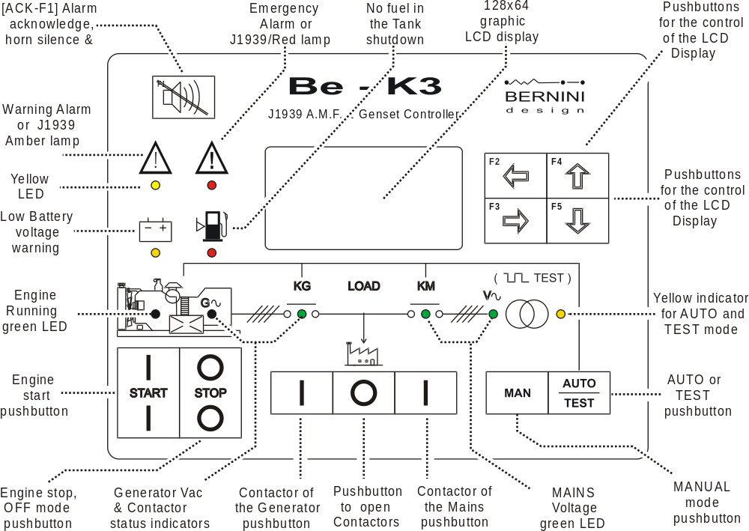

Section 2.0 - Selecting an Operational Mode

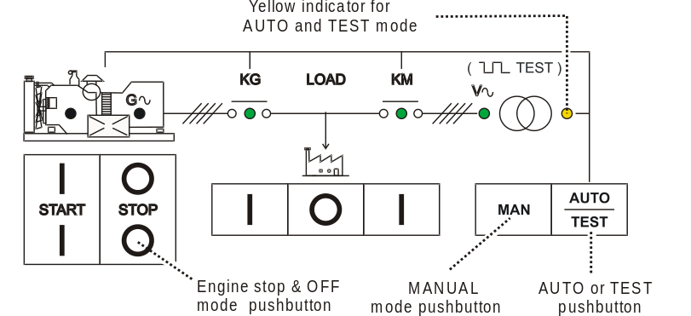 | The mode of operation is selected by pushbuttons.  If the Be-K3 was in TEST or AUTO prior to power down, when you switch on the power supply, the Be-K3 enters the AUTO mode. In the other cases, the Be-K3 will enter the OFF mode.  The following sections describe the modes of operation

Section 2.1 - OFF mode

Push and hold, for 2-3 seconds, the [ 0-STOP ] pushbutton: you turn OFF the Be-K3 and clear the fault alarms. You are allowed to program the parameters or modify settings (section 9.0 ). Push [ MAN ] or [ AUTO-TEST ] pushbutton on the front panel to turn on the Be-K3.

Section 2.2 - MAN (manual) mode

The MAN mode allows you to manually control the engine and contactors.

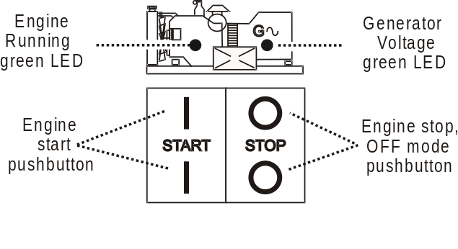 | Instructions
Push the [MAN] pushbutton to select the MAN mode. Push one of the [I-START] pushbutton until engine starts; the display will automatically open the ‘ENGINE STATUS PAGE’ with information about the start sequence (see section 5.04A). During cranking the Be-K3 turns off the light of the display.
When the engine is running, the green LED, on the engine drawing, turns on. To stop the engine, push one of the [0-STOP] pushbutton until the [STOPPING] message appears on the display. If the engine has already stopped, it is possible to reset the stop sequence by pressing the [0-STOP] pushbutton.

Section 2.21 - Manual Control of the Contactors

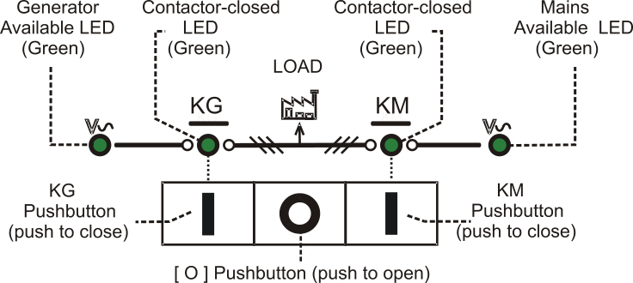 | To control the contactors follow the instructions:
Select the MAN mode, start the engine (see 2.2) and wait until the green LED Generator Available turns on.
Push the [ KG ] pushbutton to close the contactor of the Generator. To transfer the load to the Mains wait for the Green Light Mains available and push the [ KM ] pushbutton: the KG will open and KM will close after a 2-seconds delay; the programmable changeover timer works only in AUTO mode.

To open a contactor, push the [ O ] pushbutton at anytime.

! ! WARNING ! ! ! ! WARNING ! !

LINE VOLTAGE IS EXPOSED WITHIN THE Be-K3 AND ANCILLARY CIRCUITRY EVEN WHEN THE GREEN LEDs ARE TOTALLY OFF

Section 2.3 - AUTO mode (Automatic mode of operation)

!! WARNING !! !! WARNING !!

The Be-K3 can start the engine at anytime. Do not work on equipment, which is controlled by the Be-K3. When servicing the engine, disconnect the battery and battery charger. We recommend that warning signs be placed on equipment indicating the above.

Push the [AUTO] pushbutton until the yellow LED illuminates. The engine starts when the Be-K3 detects a Mains failure (see section 9.01 for settings). The contactor of the Mains opens after the [MAINS BREAKER] timing. After the [WARM UP] time if the voltage and frequency are within the settings, the contactor of the Generator will close (see section 9.02A for the settings). If the Mains restores, the KG will open. The KM will close following a programmed [KM CHANGEOVER] timing.
The engine will stop after a [ COOL DOWN ] time. If the engine shuts down, because of an alarm, the KM closes independently of the Mains status if the [ NFPA-110 ] is on (section 9.06 and application note 18.20), otherwise the KM will close only if the parameters of the Mains are within the programmed settings. In AUTO mode, the Be-K3 will periodically test the engine if the periodic test is correctly programmed (section 8.02). During the test, the yellow LED of the AUTO mode will continue to blink. In AUTO mode, the Be-K3 can start and stop the engine if a remote control is activated (Table 9.07 options [25] or [26]). You can stop the engine at anytime by selecting the MAN mode. (*)NOTE

Section 2.4 - TEST mode

Push and hold the [ AUTO ] pushbutton until the yellow LED starts to blink. The Be-K3 will start the engine and transfer the load to the Generator only in case of Mains failure if not otherwise programmed by the parameter
[ KG TEST CONTROL ] (section 8.03). To exit the TEST mode, push the [ AUTO ] pushbutton shortly or select an another mode of operation. (*)NOTE

(*)NOTE: If you push the [ 0-STOP ] pushbutton when the Be-K3 is in AUTO or TEST, the [LOCAL EMERGENCY] alarm will energize (section 13.02A). To clear the alarm, select the OFF mode.

Section 3.0 - LEds iNDICATORS / TeST OF THE LAMPS (LEDS)

The table describes the LEDs functions on the front panel (section 1, figure 1). To test the LEDs, select the OFF mode and push + hold the [←F2] and [F3→] pushbuttons simultaneously. In case of NFPA 110 application, program an input with option [14] and connect an external pushbutton (see application note on section 18.20).

LED(s) | Note |  | LED(s) | Note
Indicators of Voltages and Contactor status  (Vac, KM, KG....) | 4 Leds (Green color). See section 2.21 for the description. |  | Manual / Auto Mode  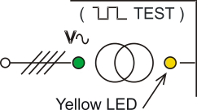 | Yellow LED  - it turns on indicating the AUTO mode  - it blinks indicating the TEST Mode
Engine Alarm Indicators   | 1 Yellow Led indicator for Battery V warning  1 Red Led indicator for  Tank Empty shutdown
 | Red Led indicator: it turns on in case of a shutdown.  Yellow Led indicator: it turns on in case of a warning. The display will indicate details of the alarm(s). |  |  | Green (Engine) LED: it turns on when the engine is running.  Green (G) LED: it turns on when the voltage of the generator is within the programmed limits.

Section 4.0 - Graphic Display- menu list

Repeatedly push [←] until the following main Menu appears. To select an item use [ ↑ ] or [ ↓ ] and push [→].

Main MENU | Section | You can: ...
METERS & ALARMS  SET DATE & TIME  DISPLAY-LANGUAGE  USER PARAMETERS  OEM PARAMETERS | 5.00  6.00  7.00  8.00  9.00 | ... read measurements, indicates alarms, events, clock  ... set the Clock  ... set the contrast of the display and select a language  ... read or configure the USER PARAMETERS  ... read or configure OEM PARAMETERS and ENGINE TYPE
RESET AND CLEAR | 10.00 | ... clear a particular area of the memory or reset counters
USER PASSWORD  OEM PASSWORD | 11.00 | ... set the OEM and USER password

After 5 minutes without operating the [ ↑ ] [ ↓ ] [ ←] [ →] pushbuttons, the display lamp will shut down. The backlight of the LCD display starts to blink around 9,5Vdc, and turnof totally below 9,0Vdc.

Section 5.0 - METERS & ALARMS

Use [ ↑ ] or [ ↓ ] to select this list of functions from the main MENU (section 4.0) and push [→]. It contains the following groups of functions.

Display Indication | Section | Description | Instructions
GENSET METERING  MAINS METERING  POWER & ENERGY  ENGINE & FUEL  ALARM MONITORING  EVENT HISTORY  SHOW DATE & TIME | 5.01  5.02  5.03  5.04  5.05  5.06  5.07 | Electrical Measurements of Generator  Electrical Measurements of Mains  Indication of Power/Energy/Power factor  Paramters of the engine and fuel  All information about alarms  Memory of the last 200 events  Indicate date and time | Use [ ↑ ] or [ ↓ ] to select a function and [→] to enter the function.  Push [←] to return back.

Section 5.01 - GENSET METERING

It indicates the following measurements (^ see NOTE):

Use [ ↑ ] or [ ↓ ] to select a page, use [ ← ] to return
L1-L2 (V) [XXXX]  L2-L3 (V) [XXXX]  L1-L3 (V) [XXXX]  FREQUENCY [XXXX] |  | L1-N (V) [XXXX]  L2-N (V) [XXXX]  L3-N (V) [XXXX]  SEQUENCE [CW/CCW] |  | CURRENT 1 [XXXX]  CURRENT 2 [XXXX]  CURRENT 3 [XXXX]  EARTH FAULT [XXXX] |  | CONTACTOR [ON/OFF]  SIMULATED (+) [ON/OFF]

(+) see option [11] in the table 9.07. It indicates that the Generator presence is simulated

^NOTE: [XXX] indicates numerical digits or [- - - -] if measurement is not available or consistent

Section 5.02 - MAINS METERING It indicates the following measurements (^ see NOTE):

Use [ ↑ ] or [ ↓ ] to select a page, use [ ← ] to return
R - S (V) [XXXX]  S - T (V) [XXXX]  T - R (V) [XXXX]  FREQUENCY [XXXX] |  | R - N (V) [XXXX]  S - N (V) [XXXX]  T - N (V) [XXXX]  SEQUENCE [CW-CCW] |  | CONTACTOR [ON/OFF]  SIMULATED (++) [ON/OFF]

(++) see option [12] in the table 9.07. It indicates that the Mains presence is simulated

Section 5.03 - POWER & ENERGY It indicates the following measurements:

Use [ ↑ ] or [ ↓ ] to select a page, use [ ← ] to return (^ see NOTE)
KVA 1 [XXXX]  KVA 2 [XXXX]  KVA 3 [XXXX]  KVA TOTAL [XXXX] |  | KW 1 [XXXX]  KW 2 [XXXX]  KW 3 [XXXX]  KW TOTAL [XXXX] |  | KVAR 1 [XXXX]  KVAR 2 [XXXX]  KVAR 3 [XXXX]  KVAR TOTAL [XXXX]
PF 1 [X.XX]  PF 2 [X.XX]  PF 3 [X.XX]  PF TOTAL [X.XX] |  | ENERGY KWH  [XXXXXX]

Section 5.04 - ENGINE & FUEL It contains information about the engine.

5.04A ENGINE STATUS PAGE
Push [ ↓ ] to browse all the other pages related to the engine and fuel

MODE OFF(*)  [MESSAGE]  --:--:-- (Time count)  KG OFF(*) KM ON(*) |  | This page indicates a messages that describes the status of the engine.  Possible [MESSAGE] are:
 |  | RUNNING | NOT RUNNING | RUN ON LOAD
 |  | REST | STARTING | CRANK
 |  | STOPPING | COOLING | WARM UP
 |  | IDLE SPEED | PREGLOW | PRELUBE
 |  | REMOTE TEST | MAINS FAILURE | MAINS RESTORE
 |  | MODE AUTO/MANUAL | PERIODIC TEST | MAINS BREAKER

Note (*) : indicates the mode of the operation of the controller and status of the contactors

- 5.04B - Engine parameters page Use [ ↑ ] or [ ↓ ] to select a page, use [ ← ] to return (^ see NOTE)

SPEED RPM [XxXX]  OIL BAR [XX.X]  COOLANT °C [XXX]  OIL °C [XXX] |  | FUEL LEVEL [XX] %  PUMP STATUS [ON-OFF]  BATTERY (V) [XX.X]  ALTERNATOR [XX.X] |  | AUX °C [XXX]  HOURS RUN [XXXXX]  N° OF STARTS [XXX]  RENTAL H (! ) [XXX] |  | SERVICE 1 (!) [XXX]  SERVICE 2 (!) [XXX]  SERVICE 3 (!) [XXX]

( ! ) It indicates the remaining hours before expiring the Maintenance timers and Rental contract (see sections 8.01 & 8.03)

NOTE: [XXX] indicates numerical digits or [- - - -] if measurement is not available or consistent

- 5.04C - Engine Miscellaneous page Use [ ↑ ] or [ ↓ ] to select a page, use [ ← ] to return (^ see NOTE)
OIL LEVEL  SPN 98 [XX]  WATER IN FUEL  SPN 97 [ON/OFF] |  | FUEL °C  SPN 174 [XXX]  FUEL BAR  SPN 94 [XXX] |  | FUEL RATE  SPN 183 [XXX]  PEDAL %  SPN 91 [XXX]
- 5.04D - Engine Miscellaneous page Use [ ↑ ] or [ ↓ ] to select a page, use [ ← ] to return (^ see NOTE)
TURBO BAR  SPN 102 [XXX]  EXHAUST  SPN 173 [XXX] |  | COOLANT %  SPN 111 [XXX]  COOLANT BAR  SPN 109 [XXX] |  | DEMANDE TORQUE  SPN 512 [XXX]  ACTUAL TORQUE  SPN 513 [XXX]

- 5.04E - Engine Miscellaneous page Use [ ↑ ] or [ ↓ ] to select a page, use [ ← ] to return (^ see NOTE)
CRANKCASE BAR  SPN 101 [XXX] |  | BOOST °C  SPN 105 [XXX] |  | INTAKE BAR  SPN 106 [XXX]  AIR FILTER BAR  SPN 107 [XXX] |  | LOAD  SPN 92 [XXX]  ECU ENGINE HOURS  [XXXXXXXXX]

NOTE: [XXX] indicates numerical digits or [- - - -] if measurement is not available or consistent

Section 5.05 - ALARM MONITORING

This menu can contain up to 9 pages of active alarms tagged with clock. A typical alarm page is indicated below (see section 13.0 for the list of all alarms):

Instructions
ALARMS PAGE 1/9  LOW OIL PRESSURE  WARNING 0,8 BAR  DD/MM/YY HH:MM:SS |  | Use [ ↑ ] or [ ↓ ] to browse the content of the pages  This page opens automatically in case of alarm(s). The alarm status is also recorded in the Memory Events register. To return push the [ ← ] pushbutton.

In case of alarms form ECU , the Be-K3 decodes the CANBUS information. Consult the user manual of the engine manufacturer for details.

ALARMS PAGE 2/9  [DESCRIPTION OF ALARM]  SPNXXX FMI XX  DD/MM/YY HH:MM:SS |  | This page opens automatically in case of alarm(s). The alarm is also recorded in the Memory Events register (see 5.06). To return push the  [ ← ] pushbutton.

Section 5.06 - EVENT HISTORY

This submenu displays 200 events providing date & time information for: warnings, shutdowns, switching of the contactors and changing of the mode of operation.

Instructions
EVENTS PAGE 1  LOCAL EMERGENCY  SHUTDOWN  DD/MM/YY HH:MM:SS |  | Push [ ↑ ] or [ ↓ ] to browse the list of the events. To return to [METERS & ALARMS] , push the [ ← ] pushbutton twice  (see section 13.0 for the description of the alarms)

Note: in order to cancel the [EVENT HISTORY], use the [CLEAR EVENTS] command described in section 10.0.

Section 5.07 - SHOW DATE & TIME

This submenu displays the real time clock (Date and Time). To modiy the settings see section 6.00.
Typical screen is indicated below:

Instructions
DAY  TIME HH:MM:SS  DATE DD/MM/YY |  | To return to [METERS & ALARMS] , push the [ ← ] pushbutton twice.

Section 6.0 - set date & time

To access this menu push [O-STOP] then, repeatedly push [←] until [METERS & ALARMS] appears on the top of the display. Push [ ↓ ] to select [set date & time]. Push [→] to enter the Menu. Set time is allowed in OFF mode of operation only.

Display Indication | Instructions
TIME 00:00:00  DATE 01/01/00 | Use [ ↑ ] or [ ↓ ] to select a function. Push [→] to enter the numerical field.  Push [ ↑ ] or [ ↓ ] to set a value. Push [←] to return.  After setting the clock, push [ ↓ ].
FORMAT DD/MM/YY | a) - If you want to change the format, push [→] and [ ↑ ] to select the option MM/DD/YY. Push [←] to return to the function; push [ ↓ ] to go on.  b) - If option DD/MM/YY is ok for you, push [ ↓ ] to proceede.
SAVE → | Push [ →] to start up the clock of Be-K3 at the proper moment (use an external clock reference)

Section 7.0 - DISPLAY & LANGUAGE

To access this menu push [O-STOP] then, repeatedly push [←] until [METERS & ALARMS] appears on the top of the display. Repeatedly push [ ↓ ] to select [DISPLAY & LANGUAGE]. Push [→] to enter the Menu.

Display | Instructions
LANGUAGE ENGLISH | A) - Use use [ ↑ ] or [ ↓ ] to select Spanish-Italian-French or English  B) - Push the [ ← ] to confirm and exit.
CONTRAST 5 | You can optimize the text-readability of the display:  - Push [→] to enter the [CONTRAST]; push [ ↑ ] or [ ↓ ] (range 0..... 15)  - Push [←] to save and exit

Section 8.0 - USER PARAMETERS (MENU)

Use [ ↑ ] or [ ↓ ] to select this Menu from the main MENU (section 4.0) and push [→] to enter the menu.
The display will present the options [READ PARAMETERS] and [MODIFY PARAMETER] (access may require password). The [USER PARAMETERS] menu contains the following functions:

Display Indication | Section | Description
SERVICE TIMERS  TEST SCHEDULER  MISCELLANEOUS  AMF SCHEDULER | 8.01  8.02  8.03  8.04 | Use [ ↑ ] or [ ↓ ] to select a function. Push [→] to enter the function.

Section 8.01 - SERVICE Timers

Use [ ↑ ] or [ ↓ ] to select this function from the [USER PARAMETERS] list (section 8.00) and push [→] to enter the function. These functions can be protected by the [USER PASSWORD].

Display Indication | Instructions
MAINTENANCE 1  OFF  MAINTENANCE 2  OFF  MAINTENANCE 3  OFF | Use [ ↑ ] or [ ↓ ] to select a function. Push [→] to select the numerical field. Push [ ↑ ] or [ ↓ ] to set a value. Push [←] to return to the function. The timers 1, 2 and 3 set the hours of Maintenance time out. Maintenance 1 and 2 will generate a warning alarm. Maintenance 3 will shutdown the engine (range 1h - 9999 hours).  The remaining time is indicated in the ENGINE & FUEL page (see 5.04B). When a timer expires, enter this screen and exit (push [←]). The timer will restart automatically.  Note: you can program an output with option [34] to drive an external relay for the function ‘MAINTENANCE TIMEOUT’.

Section 8.02 - AUTOMATIC TEST (test sCHEDULER)

Use [ ↑ ] or [ ↓ ] to select the [TEST SETTINGS] from the [USER PARAMETERS] list (section 8.00) and push [→] to activate the menu. These functions can be protected by USER PASSWORD.

Display Indication |  |  | Description
MO  TU  WE  TH  FR  SA  SU | START  --:--  --:--  --:--  --:--  --:--  --:--  --:-- | STOP  --:--  --:--  --:--  --:--  --:--  --:--  --:-- | Automatic Test setting. You can set the day/time of the Periodic Test.  Instructions:  Use [ ↑ ] or [ ↓ ] to select a function. Push [→] to enter the numerical field.  Push [ ↑ ] or [ ↓ ] to set a value. Push [←] to return to the function.  Automatic test triggers a start only if Be-K3 is in AUTO mode of operation. The yellow LED blinks during the Test (you can set an output with option [55] that activates during the Automatic test)

Section 8.03 - MISCELLANEOUS

Use [ ↑ ] or [ ↓ ] to select [MISCELLANEOUS] from the [USER PARAMETERS] list (section 8.00) and push [→] to activate the menu. These functions can be protected by User password.

Display Indication | Description
RENTAL CONTRACT OFF | You can set up to 9999 hours of rent contract. When the remaining hours drop to less than 48, the [RENTAL WARNING] alarm sets off. At zero hours, the engine will shutdown. You are required to re-program the timer. Option OFF disables the [RENTAL CONTRACT] function.
KG TEST CONTROL OFF | Options: ON or OFF.The option ON will transfer the Load to the Generator when TEST mode of operation is active. The option OFF will allow you to run the engine in TEST mode without switching the Load. Mains Failure overrides the option OFF; it will transfer the load to the generatoror.
EJP 5sec  (Effacement des Jours de Pointe). | (Range 1sec - 99 minutes). This timer delays the switching of the contactor of the Generator (KG) if the engine has been started using the EJP (see table 9.07, option [13]).
RUN TIMEOUT OFF | Maximum time allowed for running the engine (1 minute up to 23 hours). The option OFF disables the time-out and the engine will run until a stop is required. In MAN mode the engine runs for unlimited time.
RS485 NODE 1 | It allows you to select the NODE address on the MODBUS network (range 1 up to 127).

Section 8.04 - Amf sCHEDULER

Use [ ↑ ] or [ ↓ ] to select the [AMF SCHEDULER] from the [USER PARAMETERS] list (section 8.00) and push [→] to activate the menu. These functions can be protected by USER PASSWORD.

Display Indication |  |  | Description
MO  TU  WE  TH  FR  SA  SU | ON(*)  00:00  00:00  00:00  00:00  00:00  00:00  00:00 | OFF(*)  24:00  24:00  24:00  24:00  24:00  24:00  24:00 | Automatic Mains Failure scheduler. You can set the day / time to limit the control of the Mains. The engine will start only in the allowed window of time between ON and OFF.  Instructions:  Use [ ↑ ] or [ ↓ ] to select a function. Push [→] to enter the numerical field.  Push [ ↑ ] or [ ↓ ] to set a value. Push [←] to return to the function.  (*) Automatic start takes place only if Be-K3 is in AUTO mode of operation.

Section 9.00 - oem PARAMETERS

Use [ ↑ ] or [ ↓ ] to select this Menu from the MENU list (section 4.0) and push [→] to enter the menu.
The display will present the options [READ PARAMETERS], [MODIFY PARAMETERS] and [ENGINE TYPE] (*). You can limit the access by inserting an OEM password. This menu contains the following groups of parameters:

OEM PARAMETER MENU | See Section: |  | OEM PARAMETER MENU | See Section:
MAINS PARAMETERS  GENERATOR PARAM.  ENGINE PARAM.  SPEED PARAMETERS  FUEL PARAMETERS  NFPA-HOURS-HORN | 9.01  9.02 A-B  9.03 A-B-C  9.04  9.05  9.06 |  | INPUTS PARAM.  OUTPUTS PARAM.  AUXILIARY °C  FUEL LEVEL  OIL PRESSURE  RESTORE DEFAULTS | 9.07 (Table)  9.08 (Table)  9.09 (Table)  9.09 (Table)  9.09 (Table)  9.10

(*) The [ENGINE TYPE] menu is described in section 9.11.

Section 9.01 - MAINS PARAMETERS note: (sec) stands for seconds, (min) stands for minutes

Display Indication | Range |  |  | Options | Note
MAINS BREAKER 5sec | 0 | 59min |  | - | In case of Mains failure, the [MAINS BREAKER] timer will delay the opening of the KM circuit breaker.
MAINS FAILURE 5sec  MAINS RESTORE 5sec | 0  0 | 23h:59min |  |  | These two timers will delay the start and stop of the engine in order to cancel false Mains Failure/Restore conditions.
KM CHANGEOVER 2.0 | 0.1sec | 15.0sec |  | - | Dead time between the switching of the contactors.
UNDER VOLTAGE 320  OVER VOLTAGE 500 | 60  60 | 9990  9990 |  | OFF  OFF | Define operating limits for the Mains. If a parameter is out of limits, a Mains failure condition will occur.  Settings of voltages are intended ‘Phase to Phase’;  for single Phase operation voltage is intended ‘Phase R to N’.  (*) RANGE UP TO 600Hz availabel on request
UNDER HZ 47.0 (*)  OVER HZ 53.0 (*) | 20.0  20.0 | 70.0 (*)  70.0 (*) |  | OFF  OFF
PHASE UNBALANCE  OFF | 10 | 999 |  | OFF | If the difference between phases rises above the setting, a Mains failure condition will take place. The option OFF disables the monitoring of [PHASE UNBALANCE]
PHASE MODE 3 PH | 1PHASE, 3PH, 3PH+CW or 3 CCW |  |  |  | 1 = Single phase, 3Ph = 3-Phases without sequence control. The option CW/CCW controls the requested sequence of Phases. In case of reverse sequence, a Mains failure condition will occur.
VAC RATIO 1.0 | 1.0 | 15.0 | - |  | It allows the use of voltage transformer extending the reading up to 9990Vac.

Section 9.02A - GENERATOR PARAMETERS note: (sec) stands for seconds, (min) stands for minutes

Display Indication | Range |  |  | Options | Note
UNDER VOLTAGE 320  BYPASS DELAY 6sec | 60  1sec | 9990  15sec |  | OFF  - | Define operating limits for the Generator. If a parameter is out of the limits, the Be-K3 triggers the alarm and can open the KG and stop the engine.  Settings of voltages are intended ‘Phase to Phase’; for single Phase operation voltage is intended ‘Phase L1 to N’.  Under V & Under Hz work only if the contactor of the Generator is closed.  The option ON in [ALTERNATOR FAIL] parameter, will shutdown the engine if the parameters of the Generator are outside of the operating range for at least 300 seconds from engine start.  (*) RANGE UP TO 600Hz availabel on request
OVER VOLTAGE 500  BYPASS DELAY 6sec | 60  1sec | 9990  15sec |  | OFF  -
UNDER HZ (*) 47.0  BYPASS DELAY 6sec | 20.0  1sec | 70.0 (*)  15sec |  | OFF  -
OVER HZ (*) 53.0  BYPASS DELAY 6sec | 20.0  1sec | 70.0 (*)  15sec |  | OFF  -
WARNING CURRENT OFF  BYPASS DELAY 6sec | 1  1sec | 9990  15min |  | OFF  -
OVER CURRENT OFF  BYPASS DELAY 6sec | 1  1sec | 9990  15min |  | OFF  -
SHORT CIRCUIT OFF  BYPASS DELAY 0.5sec | 1  0.0sec | 9990  15.0sec |  | OFF  -
ALTERNATOR FAIL OFF | ON or OFF
PHASE MODE 3 PH | 1PHASE, 3PH, 3PH+CW or 3 CCW |  | 1= single Phase, 3=3 Phases without sequence control. The option CW/CCW controls the requested sequence of Phases. In case of reverse sequence, the engine will shutdown.

Section 9.02B - GENERATOR PARAMETERS note: (sec) stands for seconds, (min) stands for minutes

Display Indication | Range |  | Options | Note
MIN KW LIMIT OFF  BYPASS DELAY 30sec | 10  1sec | 9990  59min | OFF  - | To monitor the kW, you can program two outputs with option [10] and [11] (see Table 9.08A). The outputs energize if kW is outside limits and reset if kW is within limits. A bypass delay should be programmed according to the characteristics of the LOAD.
MAX KW LIMIT OFF  BYPASS DELAY 30sec | 10  1sec | 9990  59min | OFF  -
KVA SHUTDOWN OFF BYPASS DELAY 30sec | 10  1sec | 9990  59min | OFF  - | If the total power KVA rises above the [KVA SHUT DOWN] limit for at least the [BYPASS DELAY] time, the Be-K3 opens the contactor and shuts down the engine, The OFF setting (>9990KVA) disables the alarm.
REVERSE POWER OFF  BYPASS DELAY 1sec | 10  1sec | 9990  15sec | OFF  - | If kW1 (or 2, 3) becomes negative and exceeds the limit, the KG opens and the engine will shutdown after a cooling down time.
PHASE UNBALANCE  OFF  BYPASS DELAY  15sec | 10  1 | 999  59sec | OFF | If the difference of voltage between phases rises above the setting, the KG opens and the engine will shutdown after a cooling down time. The option OFF disables the Unbalance monitoring.
EARTH FAULT OFF  BYPASS DELAY 1.0sec | 0.1  0.3sec | 99.9  10sec | OFF  - | Provides Earth Fault current (or Differential Protection) Monitoring.
CT SIZE L1 L2 L3 500 | 5 | 9990 | - | It defines the sizes of the C.T. for the phases L1-2-3 of the Generator.
CT SIZE EARTH 50 | 5 | 9990 | - | It defines the size of the C.T. for the Earth Current
VAC RATIO 1.0 | 1.0 | 15.0 | - | It extends the reading range of the Vac up to 9990Vac  (in this case a voltage transformer is mandatory)

Section 9.03A - ENGINE PARAMETERS note: (sec) stands for seconds, (min) stands for minutes

Display Indication | Range |  | Options | Note
PRE-LUBE TIME 1 sec | 1 sec | 15 sec | It energizes the Pre-lube pump (option [63], section 9.08B) or it delays the crank if necessary (option [46],section 9.08A).
CRANK TIME 5 sec  CRANK REST TIME 5 sec  START ATTEMPTS 3 | 1 sec  3 sec  3 | 15 sec  15 sec  15 | These parameters define the start sequence of the engine.
CRANK VDC 8.0  CRANK VAC 60  CRANK HZ 25.0  CRANK RPM 300 | CRANK TERMINATION  The Be-K3 terminates the crank when one of the following parameter rises above the setting (Vdc/Vac/Hz/RPM).
CRANK VDC 8.0  CRANK VAC 60  CRANK HZ 25.0  CRANK RPM 300 | 3.0 | 30.0 | OFF | Charger alternator voltage [Vdc]
CRANK VDC 8.0  CRANK VAC 60  CRANK HZ 25.0  CRANK RPM 300 | 60 | 9990 | OFF | Generator Voltage Line to Neutral [Vac]
CRANK VDC 8.0  CRANK VAC 60  CRANK HZ 25.0  CRANK RPM 300 | 20.0 | 70.0 | OFF | Generator Frequency [Hz]
CRANK VDC 8.0  CRANK VAC 60  CRANK HZ 25.0  CRANK RPM 300 | 100 | 800 | OFF | Speed of the engine (ECU or calculated from the frequency of the Generator according to the number of poles) [RPM]
PREGLOW TIME OFF  PREGLOW MODE 1 | 1sec  - | 15min  - | OFF  1-2-3-4 | Choose (see figure 9.03A ) the proper working logic for Pre-glow (option [46] is provided to drive the pre-glow relay).
WARMUP TIME 15sec | 0 | 59min | - | The Generator Contactor will close after [WARM UP].  You can program Option [49] for a configurable output.
COOLING TIME 15sec | 0 | 59min | - | The engine will run Off-Load during the [COOLING TIME]  You can program Option [48] for a configurable output.
GAS PURGE 1sec | 1sec | 15sec | OFF | It allows you to use a GAS fuelled engine; (Program an output with option [47], see table 9.08A).
STOP SOLENOID 2 sec | 1sec | 15min | - | Energized to stop solenoid timing (set a programmable output with option [80])
BELT BREAK 8.0 | 3.0 | 30.0 | OFF | Setting to detect Charger Alternator Failure / belt break
FAIL TO STOP OFF | ON | OFF | - | Enables the Fail to Stop alarm
BYPASS TIMER 10sec | 2sec | 99sec | - | Bypass timing for Oil/Temperature /Alarm programmed with options ‘BYPASS’. See parameters on Table 9-07 with this symbol: (****) .

Figure 9.03A: Preglow-modes timing diagram

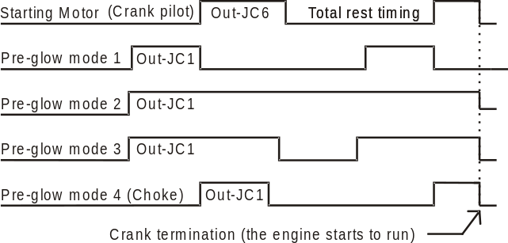

Section 9.03B - COOLANT TEMPERATURE

Display Indication | Range |  | Options | Note
HIGH COOLANT SD OFF  HIGH COOLANT WRN OFF  LOW COOLANT WRN OFF | 1  1  1 | 250  250  250 | OFF  OFF  OFF | It allows you to monitor the Coolant Temperature.  You can set a Low / High limit. The alarms are ignored during By-pass timing. Coolant temperature information is provided by the CANBUS. If not available, you can use a sensor connected to INPUT#6 and use the settings indicated in section 9.03E.

Section 9.03C - OIL PRESSURE SETTINGS

Display Indication | Range |  | Options | Note
LOW BAR WARNING OFF  LOW BAR SHUTDOWN OFF | 0.1  0.1 | 20.0  20.0 | OFF  OFF | It allows you to monitor the Oil Pressure.  You can set a Low Oil Pressure warning and/or shutdown. The alarm is ignored during By-pass timing. If you have an engine with ECU, the Be-K3 will pickup the measurement from CANBUS. If a non-ECU engine is used, you can connect a sensor to input # 4 (see also section 9.11). If you use only a Pressure Switch, program the parameters to [OFF].

Section 9.03D - OIL TEMPERATURE SETTINGS

Display Indication | Range |  | Options | Note
HIGH OIL °C WRN OFF  HIGH OIL °C SD OFF | 1  1 | 250  250 | OFF  OFF | It allows you to monitor the Oil Temperature.  The alarm is ignored during By-pass timing.  Oil temperature measurement must be provided by CANBUS (see user manual of the engine). If the ECU does not provide the OIL °C measurement, program the parameteres to [OFF].

Section 9.03E - AUXILIARY TEMPERATURE SETTINGS

Display Indication | Range |  | Options | Note
HIGH AUX°C WRN OFF  HIGH AUX °C SD OFF | 1  1 | 250  250 | OFF  OFF | It allows you to monitor the Auxiliary Temperature (input provided by an extenal resistive sensor. In case of a standard engine (without ECU) you can use this function to monitor the coolant temperature. The Be-K3 monitors the sensor connected on input #6.

Section 9.04 - SPEED PARAMETERS note: (sec) stands for seconds, (min) stands for minutes

Display Indication | Range |  | Options | Note
UNDER SPEED OFF  BYPASS DELAY 6sec  OVERSPEED OFF  BYPASS DELAY 1sec | 100  1sec  100  1sec | 4000  15sec  4000  15sec | OFF  -  OFF  - | The overspeed setting is automatically increased 5 %, during [BYPASS TIMER] (section 9.03A)
DROOP SETTING OFF | 0.1 | 10.0 | % | Setting of the droop for parallel applications.
NUMBER OF POLES 4 | 2 | 4 | OFF | It calculates the speed using the frequency of the Generator voltage. It overrides the speed detected by ECU. Set to OFF if you want to read the speed transmitted by ECU.
IDLE TIME OFF | 1sec | 59min | OFF | Program the option [60] on one digital output. The output will remain active for the all [IDLE TIME] after engine start. You can set the [IDLE SPEED] (see below)
IDLE SPEED OFF | 100 | 4000 | RPM | Setting of the IDLE speed.
NOMINAL SPEED 1500 | 100 | 4000 | RPM | You are required to set the nominal speed

Section 9.05 - FUEL PARAMETERS note: (sec) stands for seconds, (min) stands for minutes

Display Indication | Min | Max | Options | Note
TANK EMPTY OFF  (note *) | 1% | 99% | OFF | Be-K3 shuts down the engine if the level drops below the limit for the [TANK EMPTY DELAY] time (see below).  Be-K3 monitors a sensor connected to input #JF5. If you do not have a sensor, see note *.
TANK EMPTY DELAY 30 min  (note *) | 15sec | 99min | OFF | Be-K3 shutdowns the engine if a low fuel condition persists for more than [TANK EMPTY DELAY]. The OFF setting provides an immediate Shutdown.
LOW FUEL WRN OFF  HIGH FUEL WRN OFF | 1%  1% | 99%  99% | OFF  OFF | It monitors the Fuel level providing an alarm warning (Bypass=15 seconds).
PUMP START OFF  PUMP STOP OFF  PUMP TIMEOUT OFF | 1%  1%  15sec | 99%  99%  59min | OFF  OFF  OFF | Program an output with option [32] to drive a pump to fill the tank. A delay of 15 seconds for start and stop is provided. The [PUMP TIMEOUT] alarm disables the output and triggers the alarm. The pump is disabled in OFF mode.

(note *) If an‘ Analog Sensor’ is not available, you can connect a Level Switch to INPUT #JF5. In this case select the [CONVENTIONAL 1] engine type from the ENGINE TYPE menu (see 9.11) and program [TANK EMPTY] to [OFF]. You can also configure one of the programmable Input 1/2/3 (#JF1-2-3) with option [35] for a Fuel Level Switch. The timer [TANK EMPTY DELAY] starts to count when the switch closes its contacts. Be-K3 allows mixed configuration: Analag sensor on #JF5 and Level Switch on one digital input programmed with option [35].

Section 9.06 - NFPA HORN HOURS note: (sec) stands for seconds, (min) stands for minutes

Display Indication | Min |  | Max | Description
NFPA 110 ON | ON or OFF |  |  | See application note in section 18.20
HORN TIMEOUT 20sec | 5sec | 59min |  | The Horn (program an output with option [79]) will automatically shutdown after time out. Program the option OFF in order to disable timeout; the only way to silence it, in this case, is by using the  button.
HOUR COUNT SET 0 | 0 | 65534 |  | You can preset the Hour counter overwriting the old value. To cancel the Counter, put [ 0 ]. It does not affect the HOUR RUN provided by ECU.

Section 9.07 - INPUT PARAMETERS

Display Indication | Options | Note
INPUT 1 OPTION [ 1 ]  INPUT 1 POLARITY N.O. | See the table 9.07 for the available options.  You can select N.O. (normally open) or N.C. (normally closed). | Terminal JF-1
INPUT 2 OPTION [ 26 ]  INPUT 2 POLARITY N.O. |  | Terminal JF-2
INPUT 3 OPTION [ 12 ]  INPUT 3 POLARITY N.O.. |  | Terminal JF-3

Table 9.07 - List of options for INPUT PARAMETERS

Option | Description |  | Option | Description
[ 0 ] | Disables the input |  | [ 18 ] | External Display [ F4↑ ] Pushbutton
[ 1 ] | Immediate Stop |  | [ 19 ] | External Display [ F5↓ ] Pushbutton
[ 2 ] | Bypass and Stop (****) |  | [ 20 ] | KG Status (feedback form the contactor of the Generator)
[ 3 ] | Cooling and Stop |  | [ 21 ] | KM Status (feedback form the contactor of the Mains)
[ 4 ] | Bypass+Cooling+Stop (****) |  | [ 22 ] | Not used
[ 5 ] | Warning only (*) |  | [ 23 ] | Not used
[ 6 ] | Bypass and Warning |  | [ 24 ] | IDLE SPEED (it holds the engine at IDLE speed)
[ 7 ] | Remote MAN Mode (**) |  | [ 25 ] | Remote engine Start (It starts the engine only)
[ 8 ] | Remote AUTO Mode (**) |  | [ 26 ] | Remote Genset Start (It starts and transfer the Load)
[ 9 ] | Remote OFF Mode (**) |  | [ 27 ] | Not used
[ 10 ] | Remote LOCK. It disable Be-K3 and stops the engine. |  | [ 28 ] | Not used
[ 11 ] | Generator simulated ON. It simulates the presence of the Generator |  | [ 29 ] | Overload (it opens the KG and shuts down the engine after a cooling down time).
[ 12 ] | Mains Simulated ON |  | [ 30 ] | Not used (reserved for tailor made versions)
[ 13 ] | EJP function (***)  (see section 8.03) |  | [ 31 ] | [ START ] External pushbutton (works only in MAN mode)
[ 14 ] | Remote Lamp test for NFPA-110 (see 18.20) |  | [ 32 ] | [ STOP ] External pushbutton (always active)
[ 15 ] | Horn Silence |  | [ 33 ] | OIL Pressure switch (program option N.C. if you use a Pressure Switch that closes contact in case of Low Pressure)
[ 16 ] | Display [F3→] Pushbutton |  | [ 34 ] | COOLANT temperature switch (program option N.O. if you use a Temperatire Switch that closes contact in case of High Temperature)
[ 17 ] | Display [←F2] Pushbutton |  | [ 35 ] | FUEL level switch (program option N.O. if you use a Level Switch that closes contact in case of Low Level)

(*) The Be-K3 detects the alarm if the engine is running. (**) We recommend that you use an AUTO-OFF-MAN switch.

(***) When you activate the input, the Be-K3 starts the engine. After EJP time, the KG will close. When you open the input, the KG opens after EJP time and the engine will stop.

(****) For the programming of the bypass timing, see section 9.03A (parameter [BYPASS TIMER])

Section 9.08 - OUTPUT PARAMETERS

Display Indication | Terminal | Options
OUTPUT 1 79 (Horn)  OUTPUT 2 0  OUTPUT 3 0 | JC1  JC2  JC3 | [ 0 ] - [80]  see table  9.08

Table 9.08A - List of the options for OUTPUT PARAMETERS

Option & description |  |  |  |  | Option & description
[ 0 ] | The Output is disabled |  |  |  | [ 28 ] | Fuel Reserve (Sensor or switch)
[ 1 ] | Under Speed Shutdown |  |  |  | [ 29 ] | High Fuel / Low Fuel Warning
[ 2 ] | Over Speed Shutdown |  |  |  | [ 30 ] | Tank Empty shutdown (Sensor or switch)
[ 3 ] | ECU Speed error |  |  |  | [ 31 ] | Fuel sender open (input #JF5)
[ 4 ] | Common speed alarms |  |  |  | [ 32 ] | Transfer Pump Output
 |  |  |  |  | [ 33 ] | Common fuel alarms
[ 5 ] |  | Under Frequency Shutdown |  |  | [ 34 ] | Maintenance SERVICE 1,2 or 3
[ 6 ] |  | Over Frequency Shutdown |  |  | [ 35 ] | NOT USED
[ 7 ] |  | Over Current / Short Circuit Shutdown |  |  | [ 36 ] | NOT USED
[ 8 ] |  | Over Current Warning |  |  | [ 37 ] | Auxiliary Alarm 1-----3: Shutdown
[ 9 ] |  | Over KVA Shutdown |  |  | [ 38 ] | Auxiliary Alarm 1-----3: Warning
[ 10 ] |  | Minimum kW Warning | See 9.02B |  | [ 39 ] | COMMON of all WARINGS
[ 11 ] |  | Maximun kW Warning | See 9.02B
[ 12 ] |  | Phase Sequence or Unbalance Shutdown |  |  | [ 40 ] | COMMON of all SHUTDOWNS
[ 13 ] |  | Reverse kW Shutdown
[ 14 ] |  | Over / Under Voltage Shutdown |  |  | [ 41 ] |  | Presence of Nominal Mains parameters
[ 15 ] |  | Overload (input option [29] Shutdown) |  |  | [ 42 ] |  | Presence of nominal Generator parameters
[ 16 ] |  | Alternator Failure / Earth Failure |  |  | [ 43 ] |  | Mains Restore Timing / Mains Failure timing
[ 17 ] |  | Common Generator alarms |  |  | [ 44 ] |  | KG Contactor of the Generator closed
 |  |  |  |  | [ 45 ] |  | KM Contactor of the Mains closed
[ 18 ] |  | Low Oil Pressure Warning  (Sensor or CAN) |  |  | [ 46 ] |  | PREGLOW output
[ 19 ] |  | Low Oil Pressure Shutdown  (Sensor / CANBUS / Oil pressure switch) |  |  | [ 47 ] |  | PURGE (gas engine valve control)
[ 20 ] |  | Common Oil Pressure alarms or sensor open alarm |  |  | [ 48 ] |  | Cooling Timing
 |  |  |  |  | [ 49 ] |  | Warm up Timing
[ 21 ] |  | Auxiliary High Temperature Shutdown  (Input #6 connected to a sensor))
[ 22 ] |  | High Temperature Shutdown  (Oil / Coolant from CANBUS / Switches) |  |  | [ 50 ] |  | RENT Warning (<48h ) or Rent expired
[ 23 ] |  | Low / High Coolant Temperature Warning  High Oil Temperature Warning |  |  | [ 51 ] |  | Engine Running Status
[ 24 ] |  | Auxiliary Temperature Sensor Open (sensor connected to input #JF6) |  |  | [ 52 ] |  | Be-K3 in OFF MODE (Status)
[ 25 ] |  | Common Coolant Temperature alarms |  |  | [ 53 ] |  | Be-K3 in MAN MODE (Status)
 |  |  |  |  | [ 54 ] |  | Be-K3 in AUTO MODE (Status)
[ 26 ] |  | High – Low Battery Voltage Warning |  |  | [ 55 ] |  | Be-K3 in TEST MODE (Status)
[ 27 ] |  | Fuel Pump Timeout Warning |  |  | [ 56 ] |  | Be-K3 in LOCK MODE (input option [10])

( * ) For the programming of the BYPASS timing for the engine alarms, see section 12.03A.

Table 9.08B - CONFIGURABLE OUTPUTS OPTIONS

Option & description |  |  | Option & description
[ 57 ] | Fail to START Shutdown |  | [ 69 ] | Common of all alarms (warnings and shutdowns)
[ 58 ] | Fail To STOP Shutdown |  | [ 70 ] | Not used
[ 59 ] | Engine Belt Break Shutdown |  | [ 71 ] | Not used
[ 60 ] | Idle Speed Control (to Governor) |  | [ 72 ] | Crank Output repeat
[ 61 ] | Parameter or Memory Error |  | [ 73 ] | ECU enable 2 (Active in MAN, AUTO, TEST modes and during the stop solenoid time)
[ 62 ] | Clock Error or Periodic Test Error |  | [ 74 ] | KM Pulse to Close (for motorized circuit breaker)
[ 63 ] | Pre-Lube Pump or Start Delay Timing |  | [ 75 ] | KM Pulse to Open (for motorized circuit breaker)
[ 64 ] | ECU Enable 1 (Active when Fuel solenoid and Stop are activated) |  | [ 76 ] | KG Pulse to Close (for motorized circuit breaker)
[ 64 ] |  |  | [ 77 ] | KG Pulse to Open (for motorized circuit breaker)
[ 65 ] | ECU STOP command |  | [ 78 ]  [ 79 ]  [ 80 ] | Not used  HORN OUTPUT  STOP SOLENOID
[ 66 ] | CANBUS RED LAMP |  | [ 78 ]  [ 79 ]  [ 80 ] | Not used  HORN OUTPUT  STOP SOLENOID
[ 67 ] | CANBUS AMBER LAMP |  | [ 78 ]  [ 79 ]  [ 80 ] | Not used  HORN OUTPUT  STOP SOLENOID
[ 68 ] | CANBUS Communication Failure |  | [ 78 ]  [ 79 ]  [ 80 ] | Not used  HORN OUTPUT  STOP SOLENOID

Section 9.09 - AUXILIARY °C / FUEL LEVEL / OIL PRESSURE (response curve)

Select the function you need from the OEM PARAMETERS (see section 9.00), by using [ ↑ ] or [ ↓ ]. Push [→] to enter the function. Push [ ↑ ] or [ ↓ ] to set a value. Push [←] to return to the function.
The following table indicates the factory settings.

Table 9.09 SENSORS RESPONSE CURVE

TEMPERATURE [INPUT #6] OIL PRESSURE [INPUT #4] FUEL LEVEL [INPUT #5]

POINT 1 °C 128  OHM 19 | You are allowed to edit 6 value for the Temperature in the range 0-250°C and 6 value for the resistance  up to 1000 OHM  (* Note) |  | POINT 1 BAR 0  OHM 10 | You are allowed to edit 6 value for the OIL pressure in the range 0-20 BAR and 6 value for the resistance up to 1000 OHM |  | POINT 1 LEVEL 0  OHM 10 | You are allowed to edit 6 value for the Fuel Level in the range 0-99% and 6 value for the resistance up to 1000 OHM
POINT 2 °C 115  OHM 26 |  |  | POINT 2 BAR 2.0  OHM 51 |  |  | POINT 2 LEVEL 0  OHM 10
POINT 3 °C 90  OHM 46 |  |  | POINT 3 BAR 4.0  OHM 86 |  |  | POINT 3 LEVEL 0  OHM € 10
POINT 4 °C 80  OHM 67 |  |  | POINT 4 BAR 6.0  OHM 122 |  |  | POINT 4 LEVEL 0  OHM 10
POINT 5 °C 70  OHM 95 |  |  | POINT 5 BAR 8.0  OHM 152 |  |  | POINT 5 LEVEL 50  OHM 95
POINT 6 °C 40  OHM 287 |  |  | POINT 6 BAR 10.0  OHM 180 |  |  | POINT 6 LEVEL 99  OHM 180

Section 9.10 - RESTORE DEFAULT

This command allows you to restore the Factory Settings. Select [OEM PARAMETERS] then [MODIFY PARAMETERS] menu. Repeatedly push [ ↓ ] until you select the [RESTORE DEFAULTS] item. Push [ →] to enter. Follow the instructions:

Display Indication | Instructions for restoring e factory settings (Defaults)
RESTORE DEFAULTS  YES NO  < > | A) - Push [←F2] to confirm or [ F3 →] to quit the function.  B) - If you push [←F2] , the Be-K3 triggers the operation and the message [DONE] appears.  C) - Push [←F2] twice to exit and save in the memory the Defaults.  Note: we recommend that you remove the supply and check the parameters

Section 9.11 - ENGINE TYPE

This menu allows you to select the proper ECU from a list of manufacturer. Follow the menu indicated in the display and make the proper choice. Due to the continuos updating of new engines the list is not indicated here.
You can also configure analog or digital input for conventional engines. Basically the main choices are:

[CONVENTIONAL 1]: #JF4(Oil Pressure) – #JF 5 (Fuel Level) – #JF 6 (Engine Temperature) are configured to work with switches. Do not program a settings for Oil-Fuel-Temperature (it can create conflicts).

[CONVENTIONAL 2]: #JF4(Oil Pressure) is configured to work with a switch, #JF5 (Fuel Level) is configured for a sensor and #JF6 (Engine Temperature) is configured to work with a switch.

[CONVENTIONAL 3]: all #JF4-5-6 inputs are configured to work with sensors. You can use a configurable input to connect switches for additional safety (see options [33]-[34]-[35] on table 9.07).

[CANBUS-J1939...& all model of ECU]: #JF4 is configured for Low Oil Pressure Switch, #JF5 is configured for Fuel Level Sensor and #JF6 is configured for Auxiliary temperature Measurement. You can use a configurable input to connect switches for additional safety (see options [33]-[34]-[35] on table 9.07).

Section 10.0 - RESET AND CLEAR

Push [O-STOP] to enter the OFF mode. Repeatedly push [←] until the message [METERS & ALARMS] appears on the top of the display. Repeatedly push [ ↓ ] to select the function [RESET AND CLEAR] (see section 4.0).
Push [→] to enter the menu for the following options.

Display Indication | Function | Note
CLEAR ALL MEMORY | Total cancellation of the memory and restoration of factory settings | To enter a function listed on the left, you have to provide a correct password as indicated in section 11.00.  Note: all functions require a confirmation as follow:  YES (PUSH [←F2]) or NO (push [F3→])
CLEAR EVENTS | It cancels the Event History, see section 5.06
CLEAR ENERGY | It cancels the counter of the Energy, see section 5.03
CLEAR NR STARTS | It cancels the counter that records the number of starts

Section 11.00 - USER or OEM PASSWORD

Push [O-STOP] to enter the OFF mode. Repeatedly push [←] until the message [METERS & ALARMS] appears on the top of the display. Repeatedly push [ ↓ ] to select the function [USER PASSWORD] or [OEM PASSWORD].
Push [→] to enter the menu for the following options.

Display Indication | Instructions
PASSWORD  CLEAR PASSWORD | The display will present the option [CHANGE PASSWORD] and  [CLEAR PASSWORD]. Use [ ↑ ] or [ ↓ ] to select a function and push [→] to enter the function; Section 11.01 describes the procedure.

Section 11.01 USER or OEM PASSWORD programming instructions

Display Indication | Instructions
INSERT PASSWORD  BACK * * * * OK  < > | A) - Use [←] or [→] to select a digit of the password.  B) - Push [ ↑ ] or [ ↓ ] to edit a number .  C) - Repeat steps A) and B) in order to edit the 4-digit password.  D) - Select OK using the [→] button (the OK backlights when selected).  E) - Push the [→] button to confirm the password.  Note: by programming [0000] you disable (clear) the password

Section 12.00 - PROGRAMMING PARAMETERS

We recommend that you use the software available on web site for programming the controller. Be-K3 however, allows programming using the push buttons on the front panel. Follow the instructions on this section.

12.01 Preliminary operation

Push and hold [O-STOP] to enter the OFF mode. Repeatedly push [←] until the message [METERS & ALARMS] appears on the top of the display. Repeatedly push [ ↓ ] to select the function [USER PARAMETERS] or [OEM PARAMETERS]. Push [→]; the following screen will appear (example of [OEM PARAMETERS])

Display Indication | Instructions
READ PARAMETERS  MODIFY PARAMETERS  ENGINE TYPE | A) - Push [→] to enter directly the [READ PARAMETERS] (section 12.05)  B) - Push [ ↓ ] to select the item [MODIFY PARAMETERS]  C) - Push [→] to enter the programming or push [ ↓ ] and then [→] if you want to modify the type of engine (section 9.11)

12.02 Type the Password

If a password was inserted, the Be-K3 will present a screen to ask for the password as indicated below, otherwise follow directly the instructions on section 12.03.

Display Indication | How to insert a password
INSERT PASSWORD  BACK * * * * OK  < > | A) - Use [←] or [→] to select a digit of the password.  B) - Push [ ↑ ] or [ ↓ ] to edit a number .  C) - Repeat steps A) and B) in order to edit the 4-digit password.  D) - Select OK using the [→] button (the OK backlights when selected).  E) - Push the [→] button to confirm the password.

12.03 Select a parameter

Choose the MENU of your interest by using the [ ↑ ] or [ ↓ ] buttons and then push [→] ; the list of the parameters will appear.

12.04 Programming a parameter

- Select a parameter by using the [ ↑ ] or [ ↓ ] buttons (see sections 8.00 and 9.00 for the list of parameters).
- Push the [→] button to enter the numerical / options field of the parameter.
- Modify the parameter using [ ↑ ] or [ ↓ ] according to your need.
- Exit the numerical/options field using the [←] pushbutton.
- You can modify an other parameter by repeating the previous steps
- Push twice the [←] pushbutton. The Be-K3 will provide you 3 options:
EXIT [← F2] SAVE BACK [F3 →]

Choose the proper option. We recommend that you disconnect the supply for a few seconds, re-apply the supply and verify that the modifications have been saved in a way that Be-K3 operates according to your need.

12.05 How to Read a parameter

To read a parameter, follow the set up indicated in section 12.01 then:
- Choose a parameter using [ ↑ ] or [ ↓ ]
- Push [→] to read the setting of the parameter
- Repeteadly push [←] to return or exit

Section 13.0 - ALARMS, Warnings and Shutdowns

The Be-K3 features:

A) – A yellow LED that turns on in case of a warning and a red LED that turns on in case of a shutdown.
B) - Symbols and LEDs, indicating the alarms of Low Fuel and Low Battery (see figure 1).
C) - Configurable Horn output (°) and specific outputs for remote / external repetition of alarms.
D) - Descriptive messages for alarms with date, time and measurement information.
E) - Event history capable of recording 200 alarms and events (see section 5.06).
F) - A pushbutton to silence the Horn ().

(°) The terminal JC-1 is factory programmed for driving an external HORN. To silence the HORN, push the pushbutton or wait for the [HORN TIMEOUT] to expire (see section 9.06). If the [HORN TIMEOUT] is set to [OFF], the only way to silence the Horn is by using the pushbutton.

Instructions in case of alarm(s):

- Look at the front panel and take note of LEDs indicators and messages on display.
- Some alarms, in order to cool down the engine, shutdown the engine after a programmable delay. We recommend that you wait the complete stop of the engine.
- Push the pushbutton in order to acknowledge the alarm. Push the [0-STOP] button.
- Consult the following sections for further information
- Remove the cause of the alarm.
- Restart the engine by using a proper Mode of operation.

The full list of alarm messages is indicated below on the left side. Additional information on the right side

13.01 - Clock and periodic test alarms |  | Section
CLOCK ERROR WARNING | Real time clock failure or wrong programming | 6.00
PARAMETER ERROR | Error in a parameter | 18.30
MEMORY ERROR | Failure of the memory | 18.30
CAN BUS ERROR WARNING | Failure of the CANBUS communication | 9.11

13.02A - Emergency alarms & Shutdowns |  | Section
LOCAL EMERGENCY SHUTDOWN | This alarm takes place if you push the [0-STOP] button when the Be-K3 is in AUTO mode of operation | -
INPUT 1 WARNING  EMERGENCY 1 SHUTDOWN | Input 1 Warning or Shutdown (input #JF-1) | 9.07
INPUT 2 WARNING  EMERGENCY 2 SHUTDOWN | Input 2 Warning or Shutdown (input #JF-2) | 9.07

13.02B - Emergency alarms & Shutdowns |  | Section
INPUT 3 WARNING  EMERGENCY 3 SHUTDOWN | Programmable Input 3 Warning or Shutdown  (input #JF-3) | 9.07
REMOTE LOCK | An input programmed with option [10] is active. The Be-K3 shuts down the engine if running. When you deactivate the input, the alarm resets automatically and Be-K3 will operate normally. | 9.07

13.03 - Miscellaneous engine alarms |  | Section
ECU SPEED ERROR | Failure in detecting the signal from Pick-up (shutdown) | 9.04
OVER SPEED SHUTDOWN | Over Speed shutdown | 9.04
UNDER SPEED SHUTDOWN | Under Speed shutdown | 9.04
LOW BATTERY WARNING | Low Battery Voltage warning: 11,8 for 12V battery and 23,6 for 24V battery. | -
HIGH BATTERY WARNING | High Battery Voltage warning:15,5V for 12V battery and 31V for 24V battery. | -
FAIL TO START  SHUTDOWN | Starting Failure shutdown | -
FAIL TO STOP  SHUTDOWN | Fail to stop shutdown | -
BELT BREAK SHUTDOWN | Engine Belt break shutdown (Charger Failure) | 9.03A

13.04 - Alternator and Contactors alarms |  | Section
OVERLOAD SHUTDOWN | Overload shutdown (any input with option [29]) | See  settings:  9.02A  9.02B
SHORT CIRCUIT SHUTDOWN | Short circuit shutdown | See  settings:  9.02A  9.02B
UNDER VOLTAGE SHUTDOWN | Under Voltage shutdown | See  settings:  9.02A  9.02B
OVER VOLTAGE  SHUTDOWN  PHASE UMBALANCE SHUTDOWN | Over Voltage shutdown  Phase unbalance shutdown | See  settings:  9.02A  9.02B
UNDER FREQUENCY SHUTDOWN | Under Frequency shutdown (works only if the KG is closed) | See  settings:  9.02A  9.02B
OVER FREQUENCY SHUTDOWN | Over Frequency shutdown | See  settings:  9.02A  9.02B
OVER KVA  SHUTDOWN | Over Apparent power shutdown | See  settings:  9.02A  9.02B
PHASE SEQUENCE SHUTDOWN | Generator Phase sequence shutdown | See  settings:  9.02A  9.02B
OVER CURRENT  WARNING | Over Current warning | See  settings:  9.02A  9.02B
OVER CURRENT  SHUTDOWN | Over Current shutdown | See  settings:  9.02A  9.02B
ALTERNATOR FAILURE | Alternator Failure shutdown | See  settings:  9.02A  9.02B
EARTH CURRENT  SHUTDOWN | Earth Failure shutdown | See  settings:  9.02A  9.02B
REVERSE POWER  SHUTDOWN | Reverse Power Shutdown | See  settings:  9.02A  9.02B
CONTACTOR KM WARNING | The Mains contactor failed to work | See  settings:  9.02A  9.02B
CONTACTOR KG WARNING | The Generator contactor failed to work | See  settings:  9.02A  9.02B

13.05 - Temperature alarms |  | Section
LOW COOLANT °C WARNING  HIGH COOLANT °C WARNING  HIGH COOLANT °C SHUTDOWN | Coolant monitoring is active when ECU transmits data. Warning or / and Shutdown. ‘SW’ stands for Temerature Switch (input #JF6 or any digital input with option [34]). | See  9.03B  9.03D  9.03E
TEMPERAURE SW SHUTDOWN |  | See  9.03B  9.03D  9.03E
OIL TEMPERATURE WARNING | Abnormal Temperature of the OIL; Warning or / and Shutdown. | See  9.03B  9.03D  9.03E
OIL TEMPERATURE SHUTDOWN | Abnormal Temperature of the OIL; Warning or / and Shutdown. | See  9.03B  9.03D  9.03E
AUX °C SENSOR WARNING  AUX °C SENSOR SHUTDOWN | Abnormal Auxiliary Temperature (Sensor connected to #JF6); Warning or / and Shutdown. | See  9.03B  9.03D  9.03E
AUX °C SENDER OPEN | Indicate the failure of a temperature sensor connected to #JF6 (resistance over 2100 Ohm) | See  9.03B  9.03D  9.03E

13.06 - Fuel Level alarms |  | Section
LOW FUEL LEVEL WARNING | Low Level Fuel warning (Sensor connected to input #JF5). | 9.05
HIGH FUEL LEVEL WARNING | High Level Fuel warning (Sensor connected to input #JF5). | 9.05
TANK EMPTY SHUTDOWN | Be-K3 shuts down the engine if the level drops (level sensor) below the limit for more than the programmed time. | 9.05
FUEL RESERVE WARNING | This warning energizes during the TANK EMPTY DELAY. It indicates that fuel is going to finish. | 9.05
PUMP TIMEOUT WARNING | This warning energizes if the PUMP to fill the tank remains activated for more than the programmed time. | 9.05
FUEL SENDER OPEN | Failure of the Fuel Sensor (input #JF5) | 9.05

13.07 - Oil Pressure alarms |  | Section
LOW OIL PRESSURE WARNING | Low Oil Pressure Warning (ECU or #JF4 input) | 9.03C  9.09
LOW OIL PRESSURE SHUTDOWN | Low Oil Pressure Shutdown (ECU or #JF4 input or Option [33])
OIL BAR SENDER  OPEN | Failure of the OIL PRESSURE sensor ( #JF4 input )

13.08 - Maintenance and Rental contract alarms |  | Section
SERVICE 1 WARNING | Maintenance 1 & 2 provide a warning after timeout. Service 3 provides a shutdown after timeout.  To cancel the alarm, reprogram the Maintenance or simply enter & exit the [MAINTENANCE] menu to restart the count. | 8.01
SERVICE 2 WARNING |  | 8.01
SERVICE 3 SHUTDOWN |  | 8.01
RENTAL 48h WARNING | Less than 48 hours remaining before engine shutdown. | 8.03
RENTAL EXPIRED  SHUTDOWN | Rental period termination. To cancel the alarm, reprogram the RENTAL or simply enter & exit the [TEST & RENTAL] program menu to restart the count | 8.03
MAXIMUM RUNTIME  SHUTDOWN | Time expired. This timer allows the engine to run a limited number of hours. If case of alarm, verify the general status of the engine, cancel the alarm and restart the engine. In MAN mode the timeout is disabled and the engine runs for unlimited time. | 8.03

Section 14.0 - Engine Running Detect

The Be-K3 inhibits the starter motor when the engine starts running. When the engine is not running, voltage in the terminal D+/WL of the charger alternator (input JI-3) is 0V. When the engine starts running, the voltage of the D+/WL terminal increases; the range to disconnect the starter motor is between 6V to 10V. The default parameter of [CRANK VDC] (section 9.03A) is 8.0V. For 24V batteries, we recommend that you set the threshold to 16V. For a safe use, be sure that the green ENGINE RUNNING LED on the front panel is off during all of the starting attempts. The Charger Alternator voltage can be displayed in the Engine menu as indicated in the section 5.04. In addition, Be-K3 monitors the Generator for disconnecting the crank motor. The insertion of switches or breakers in series to terminals #JA5-6-7 is not recommended; the Be-K3 will not detect the engine running condition from the Generator Voltage or Frequency. See the [CRANK VAC] and [CRANK HZ] parameters in section 9.03A.

NOTE: THE ENGINE RUNNING LED MUST BE LIT WHEN THE ENGINE RUNS. USING THE ENGINE WITHOUT THIS SIGNAL MAY BE DANGEROUS.

Section 15.0 - Troubleshooting Guide

Troubleshooting for Be-K3 is performed by selectively isolating the failure of the various circuit sections. We recommend that you disconnect the unit from the panel and set up the troubleshooting application circuit as indicated in section 15.01. This procedure should be carried out by qualified personnel only.

! ! W A R N I N G ! !
High voltage is present inside this instrument. To avoid electric-shock hazard, operating personnel must not remove the protective cover. Do not disconnect the grounding connection. Any interruption of the grounding connection can create an electric shock hazard. Before making external connections, always ground the Be-K3 first by connecting the control panel to ground.

Section 15.01 Troubleshooting Set up Circuit

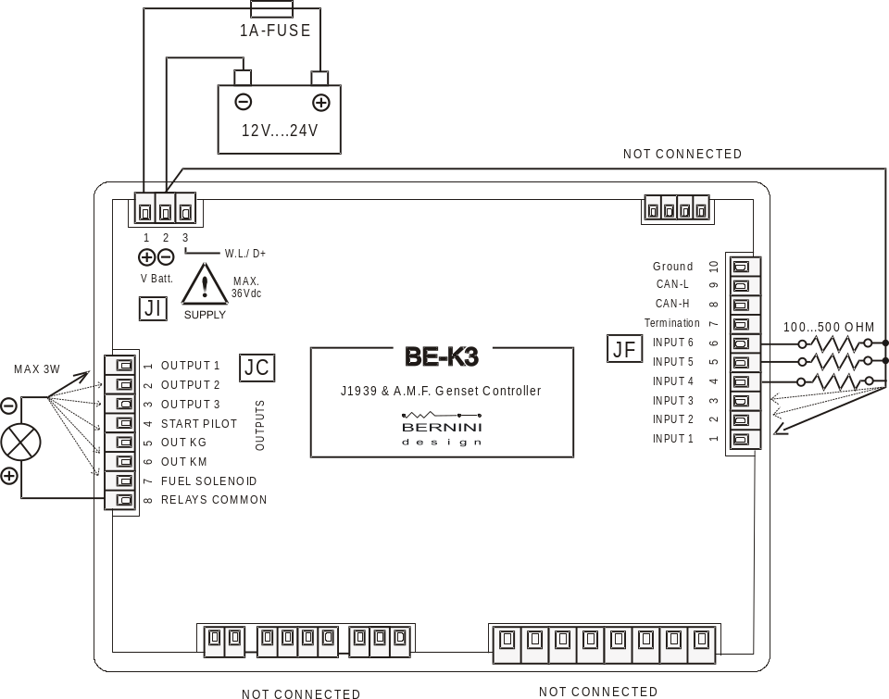

Section 15.01 - Testing the Pushbuttons

Follow the instructions:

A) - Remove the battery power supply; disconnect all connectors
B) - Push and hold the pushbutton, apply the Vdc power supply.
C) - Release the button; the message [ KEYS TEST ] will be displayed on the screen.
D) - Push the pushbuttons on the front panel one by one. The display will show a message indicated in Table 15.01. As soon as you release a button, the message disappears (no buttons activated).

Table 15.01: Pushbuttons true table

Pushbutton | Display Message | Pushbutton | Display Message
[ START ] | START | [AUTO-TEST] | AUTO-TEST
[ STOP ] | STOP |  | ACK-F1
[ I - KG ] | KG | [F2 ←] | F2-LEFT
[ O ] | OPEN | [F3 → ] | F3-RIGHT
[ I - KM ] | KM | [F4 ↑ ] | F4-UP
[ MAN ] | MANUAL | [F5 ↓ ] | F5 - DOWN

To exit the troubleshooting remove the Vdc power supply at anytime

Section 15.02 - Testing the Inputs

D) – Push pushbutton until the message [INPUT TEST] appears on display. Connect to the battery minus, one by one, the inputs #1...#3 on the connector JF. For each input, a code will be displayed (see Table 15.02). If some inputs are connected simultaneously (in case of short circuit for example), the display will indicate the inputs that are activated together. When all inputs are disconnected the display must indicate only the message [INPUT TEST] .

NOTE - At this stage, with all inputs disconnected, if the display indicates one of the codes contained in Table 15.02, the Be-K3 is damaged and should be returned to Bernini Design for repair.

Table 15.02

Terminal number (Function) | Display Code
JF-1 (Input 1) | INPUT 1
JF-2 (Input 2) | INPUT 2
JF-3 (Input 3) | INPUT 3

To exit the troubleshooting remove the Vdc power supply at anytime

Section 15.03 - Testing the Outputs

A) - Push the pushbutton, for about 5 seconds, until the message [OUTPUT TEST] appears.
B) - Plug the connectors JC as indicated in the section 15.01. At this stage, if a lamp turns on, the Be-K3 is damaged and should be returned for service.
C) - Push in sequence, the pushbuttons as indicated in the Table 15.03. A message will indicate that the output is activated: the lamp connected should activate as long as you push and hold the button.

Table 15.03: Output true table Indicates the correspondence for each message. If a lamp fails to turn on or always remains activated, the Be-K3 is damaged and should be returned for service.

Pushbutton | Message | Output
[ O ] | OUTPUT 1 | JC1
[ MAN ] | OUTPUT 2 | JC2
[ AUTO-TEST ] | OUTPUT 3 | JC3
[ START ] | OUTPUT START | JC4
[ I - KG ] | OUTPUT KG | JC5
[ I - KM ] | OUTPUT KM | JC6
[ STOP ] | FUEL SOLENOID | JC7

Section 15.04 - Testing the Sensors

A) - Push the pushbutton, for about 5 seconds, until the page of analog measurements appears.
B) - Compare the indication with an external instruments. If the value indicated by the display is more than 3% (or less than 3%), the Be-K3 is damaged and should be returned for service.

Table 15.04 - Analog measurements

Terminal  number | Indication of the Display (°) | Recommended values for testing the measurements
#JF-4 | OIL OHM [XXX] | 100 up to 500 Ohm
#JF-5 | FUEL OHM [XXX] | 100 up to 500 Ohm
#JF-6 | AUX C OHM [XXX] | 100 up to 500 Ohm

(°) Note [X--X] indicates a numerical field.

To exit the troubleshooting remove the Vdc power supply at anytime

Section 16.0 - General Specifications

Supply voltage: 5.5Vdc to 36Vdc, 50-150mA. Protection: internal 300mA thermal fuse.

Dimensions:: 192mm X 144mm X 40mm. Panel Cut-out: 187mm X 139mm, indoor operation

Operating temperature range: -25 deg C up to +70 deg C. Humidity range: 5% up to 95% non-condensing.

Weight: 710 grams General design: ECC 89/336, 89/392, 73/23, 93/68, IEC 68-2-6. Certification: CE

Static outputs characteristics: Output Current: 300mA/100Vdc short circuit proof. Logic: negative.

Supply output for relays (terminal JC8): Max 1A at V battery minus 1Vdc (short circuit proof).

Mains and Generator voltage input: Nominal Voltage input: 70 Vac-600Vac. Over voltage: 4KVac phase to neutral. Measurement precision: +/- 2%. Input impedance: 2 Mega Ohm

Current transformer input size: 10/5Aac up to 9900/5Aac. Maximum admissible permanent current: 7Aac
Measurement precision: +/- 2%. Internal resistance: 0.05 Ohm

Digital inputs: Open circuit voltage: Battery voltage minus 2V - Trigger level: < 2Vdc (max 15mA).

Charger alternator monitoring: Operating voltage up to 36Vdc/3W. Vdc reading accuracy +/- 5%.

Section 17.0 - Software Upgrades & Revisions

Firmware  Versions | Date | User manual | Description
1.XX | June 2010 | V01.33 | CanBus upgrade-first release
3.XX | July 2011 | V300 | French language correction
3.3X | Jan. 2016 | V400 | Current transformers connected on LOAD side

Section 18.0 - Application Notes

18.1 - Single Phase operation

A) - Program the parameter [ PHASE MODE ] for the Mains (section 9.01) to [ 1PHASE ] .
B) - Program the same as above for the Generator (section 9.02A).
C) - Connect Mains Live to #JA-1 (R) and neutral to #JA-4 (N).
D) - Connect Generator Live to #JA-5 (L1) and neutral to #JA-8 (N). You are required to adjust the parameters Over/Under voltage according to your requirements.

Note Be-K3 allows mixed selections: Three-Phase Mains and Single Phase Generator or viceversa.

18.2 – NFPA110 MODE, BASIC INFORMATION

To comply with the NFPA110 standard, the ON option in the parameter [ NFPA 110 ] (see section 9.06) needs to be enabled. It is then required to perform the following basic operations:

- Install an external 3-position switch RUN-OFF-AUTO for selecting the mode of operation
- Connect the RUN terminal of the switch to a programmable input with option [ 26 ] (Remote Genset start)
- Connect the AUTO terminal of the switch to a programmable input with option [ 8 ] (Remote AUTO mode)
- Connect the OFF terminal of the switch a programmable input with option [ 9 ] (Remote OFF Mode).
- Connect the other side of the RUN,OFF and AUTO contacts to the battery minus.
- Connect a relay to a Programmable output in order to drive a lamp. The lamp turns on if the Be-K3 is NOT IN A AUTO MODE (use the normally closed contact of the relay)
- Program the output with the option [54] (See Table 9.08A, Be-K3 in AUTO mode status)
- Program one input with option [14] (Remote Lamp test) and connect an external pushbutton.
- Consult the NFPA110 documentation and verify if other settings are required.

18.3 – MEMORY ERROR & PARAMETER ERROR

The message [MEMORY ERROR] or [PARAMETER ERROR] indicate a DATA corruption.
In order to clear the alarm, follow the instructions below:

( A ) – Remove the power supply for a minute.
( B ) – Reconnect the power supply. If the message disappears you can continue using the controller without problem.

If the message persists on the display, follow these instructions

( C ) – Push the pushbutton in order to cancel the alarm
( D ) – Enter the Programming (see section 9.0)
( E ) – Select the function CLEAR MEMORY. If the message [DONE] appears, you can reprogram the controller.
If the Be-K3 returns the message [MEMORY ERROR], the controller is damaged and should be returned to Bernini Design for service

Section 19.0 - Panel & Gen-set Builders Notes

Section 20.0 - Typical application

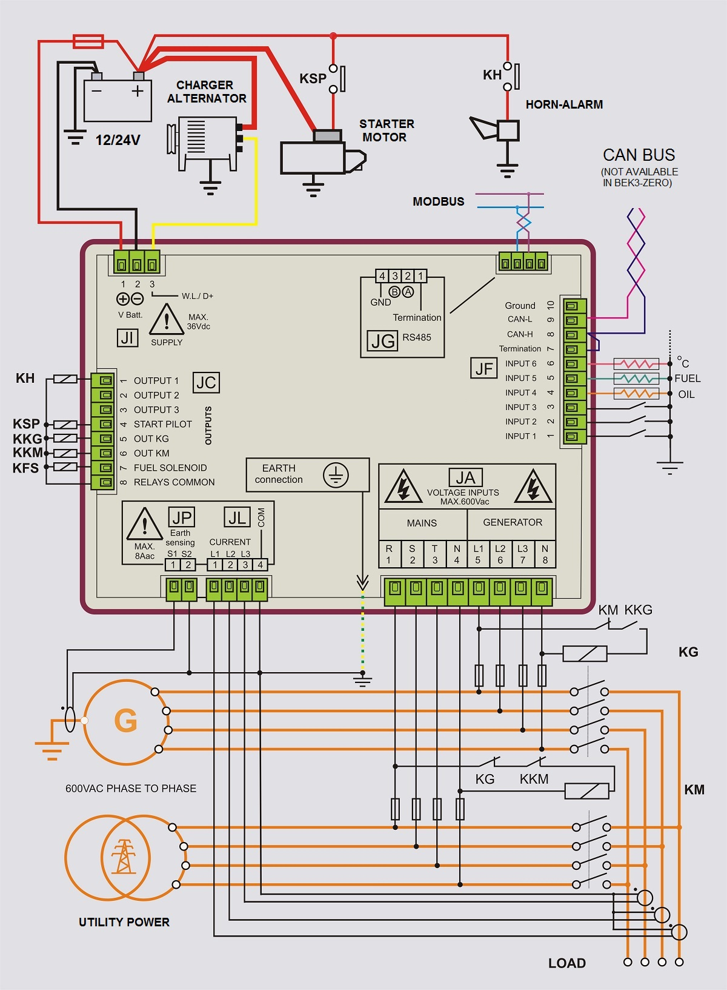

Section 21.0 - Rear view and dimensions

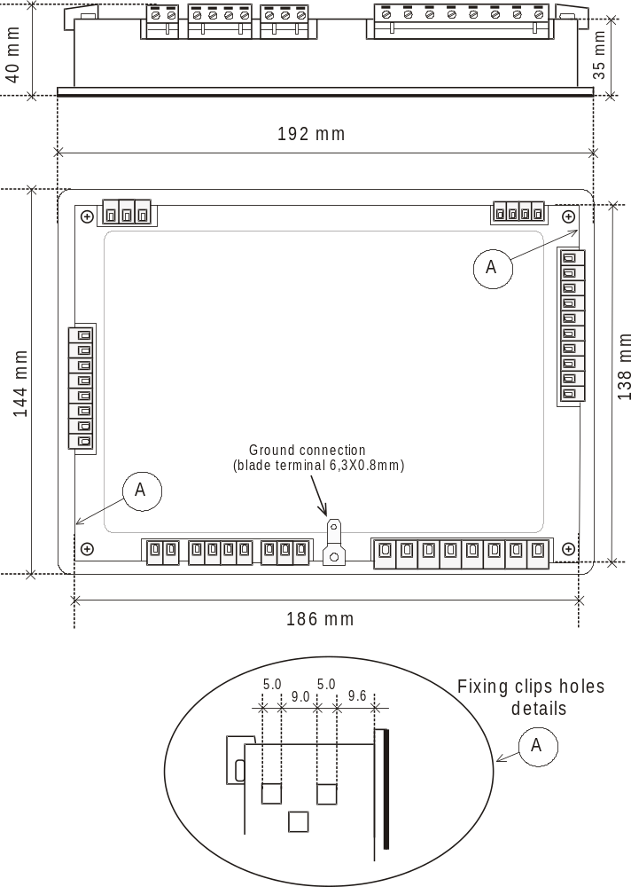

Recommended hole size (mm): 187 X 139
Overall dimensions (mm): 192 X 144 X 40
Shipping dimensions (mm): 215 X 150 X 50

Section 22.0A - Terminal description (1 of 2)

!! WARNING !!
ANY INTERRUPTION OF THE PROTECTIVE GROUND OR DISCONNECTION OF THE PROTECTIVE EARTH IS LIKELY TO MAKE THE Be-K3 DANGEROUS

Terminal | Description & Notes
#JA-1 | Mains  voltage  600Vac | R | Inputs for Mains and Generator monitoring up to 600Vac.  Neutral connection is not a mandatory requirement but provides improved measurement precision.  For Single Phase operation use terminals R/Neutral for the Mains and L1/Neutral for the Generator (see also section 18.10)
#JA-2 | Mains  voltage  600Vac | S
#JA-3 | Mains  voltage  600Vac | T
#JA-4 | Mains  voltage  600Vac | Neutral
#JA-5 | Generator  voltage  600Vac | L1
#JA-6 | Generator  voltage  600Vac | L2
#JA-7 | Generator  voltage  600Vac | L3
#JA-8 | Generator  voltage  600Vac | N

#JC-1 | Configurable Output 1 | See section 9.03A for programming
#JC-2 | Configurable Output 2 | See section 9.03A for programming
#JC-3 | Configurable Output 3 | See section 9.03A for programming
#JC-4 | Start Pilot output | It drives the Starting Motor. See [ CRANK TIME ] on section 9.03A.
#JC-5 | Contactor Generator output | It drives the Auxiliary KKG relay of the KG (see 20.00)
#JC-6 | Contactor of the Mains output | It drives the Auxiliary KKM relay of the KM (see 20.00)
#JC-7 | Fuel Solenoid output | Energized to run output for Fuel solenoid and ancillary circuitry.
#JC-8 | Output supply for external relays. | It provides supply for the common of the output relays (max current 1A). The voltage is V Battery minus 0,5V.

#JF-1 | INPUT 1 | See section 9.07 for programming
#JF-2 | INPUT 2 | See section 9.07 for programming
#JF-3 | INPUT 3 | See section 9.07 for programming
#JF-4 | INPUT 4  (Oil Pressure Sensor/ Switch) (^) | This input monitors the Oil pressure sensor. See settings on section 9.03C and 9.09 for the programmable curve response.  The input can be configured to digital mode in ENGINE TYPE menu (^).
#JF-5 | INPUT 5  (Fuel Level Sensor/Switch) (^) | This input monitors the FUEL LEVEL sensor. See settings on section 9.05 and 9.09 for the programmable curve response.  The input can be configured to digital mode in ENGINE TYPE menu (^).
#JF-6 | INPUT 6  (Temperature Sensor/Switch) (^) | This input monitors the TEMPERATURE sensor. See settings on section 9.03E and 9.09 for the programmable curve response.  The input can be configured digital in the ENGINE TYPE menu (^).
#JF-7 | Termination | 120 Ohm connection point. It allows you to terminate the CANBUS connection (impedance 120 OHM)
#JF-8 | CAN HIGH | To be connected to the CAN HIGH of the ECU
#JF-9 | CAN LOW | To be connected to the CAN LOW of the ECU
#JF-10 | Ground | Connection of the shield (if required by the aplication)

(^) [CONVENTIONAL 1]: #JF4(Oil Pressure) – #JF 5 (Fuel Level) – #JF 6 (Engine Temperature) are configured to work with switches. Do not program a settings for Oil-Fuel-Temperature (it can create conflicts). SEE 9.11 TO SELECT AN ENGINE.

(^) [CONVENTIONAL 2]: #JF4(Oil Pressure) is configured to work with a switch., #JF5 (Fuel Level) is configured for a sensor and #JF6 (Engine Temperature) is configured to work with a switch. SEE 9.11 TO SELECT AN ENGINE.

(^) [CONVENTIONAL 3]: all #JF4-5-6 inputs are configured to work with sensors (all analogue inputs). You can use a configurable input to connect switches for additional safety (see options [33]-[34]-[35] on table 9.07). SEE 9.11 TO SELECT AN ENGINE.

(^) [CANBUS-J1939]: #JF4 is configured for Low Oil Pressure Switch, #JF5 is configured for Fuel Level Measurement and #JF6 is configured for Auxiliary temperature Measurement. You can use a configurable input to connect switches for additional safety (see options [33]-[34]-[35] on table 9.07). SEE 9.11 TO SELECT AN ENGINE.

Section 22.0b - Terminal description (2 of 2)

#JG-1 | Termination 120 OHM | RS485 serial interface.  Consult the Be-485/USB converter User Manual for further information.
#JG-2 | SIGNAL A
#JG-3 | SIGNAL B
#JG-4 | Common Ground

#JI-1 | Plus Battery Vdc supply | An internal Electronic 1A Thermal Protection is provided.
#JI-2 | Battery minus supply | An internal Electronic 1A Thermal Protection is provided.
#JI-3 | D+ or W.L. driver | Must be connected to D+/W.L. in order to excite the charger alternator and detect the ‘Engine Running’ status.

#JL-1 | Current Transformer L1 (S2) | Inputs for the Current Transformers.  The nominal Current is 5A.  To program the size see section 9.02B
#JL-2 | Current Transformer L2 (S2)
#JL-3 | Current Transformer L3 (S2)
#JL-4 | Current Transformer Common | S1 terminal of each CT must be grounded

#JP-1 | Current transformer for Earth Fault sensing | See section 9.02 for the settings  Terminal JP-2 must be grounded
#JP-2 | Current transformer for Earth Fault sensing

